VISVESVARAYA TECHNOLOGICAL UNIVERSITY
“Jnana Sangama”, Belagavi-590018

SKILL DEVELOPMENT ACTIVITY REPORT ON BLOCKCHAIN TECHNOLOGY(MSCS214A) TOPIC: SUPPLY CHAIN TRANSPARENCY
Submitted in partial fulfillment of the requirements for the award of the degree of

MASTER OF TECHNOLOGY
IN

DEPARTMENT OF COMPUTER SCIENCE AND ENGINEERING
Submitted by

BHOOMIKA N RAGHAVI C S
1KS24SCS01
1KS24SCS05

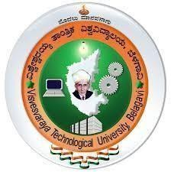

Under the guidance of
Dr. Sunita Chalageri Associate Professor
Department of Computer Science and Engineering K.S.I.T
Bengaluru-560109

Department of Computer Science and Engineering

K. S. INSTITUTE OF TECHNOLOGY
#14, Raghuvanahalli, Kanakapura Road, Bengaluru- 560109
2024-2025

